Hotel (hotelNo, hotelName, city)

Room (roomNo, hotelNo, type, price)

Booking (hotelNo, guestNo, dateFrom, dateTo, roomNo)

Guest (guestNo, guestName, guestAddress)

Tables are:

Hotl:

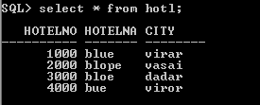

Rom:

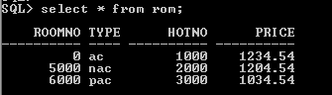

Bookin:

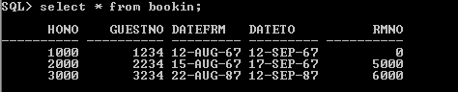

Gui:

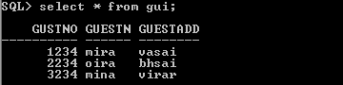

1. List the price and type of all rooms at the Grosvenor Hotel.
2. select type,price
3. from rom
4. where hotno=(select hotelno from hotl
5. where hotelname = 'blue');
6. 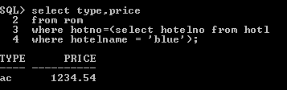
7. List all guests currently staying at the Grosvenor Hotel.
8. select guestname
9. from gui
10. where gustno = (select guestno from bookin
11. where hono = (select hotelno from
12. hotl
13. where hotelname = 'blue'));

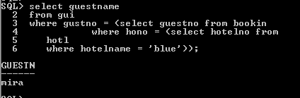

List the details of all rooms at the Grosvenor Hotel, including the name of the guest staying in the room, if the room is occupied.

1. What is the total income from bookings for the Grosvenor Hotel today?
2. List the rooms that are currently unoccupied at the Grosvenor Hotel.
3. What is the lost income from unoccupied rooms at the Grosvenor Hotel?
4. List the number of rooms in each hotel.
5. List the number of rooms in each hotel in London.
6. select count(roomno)
7. from rom
8. where hotno = (select hotelno from hotl
9. where city ='virar');
10. 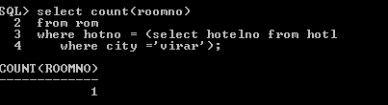
11. What is the average number of bookings for each hotel in August?
12. What is the most commonly booked room type for each hotel in London?
13. What is the lost income from unoccupied rooms at each hotel today?